**NAB AFL Auskick Coordinator Newsletter**

**Keep up to date with all our news and important information around your child’s Auskick!**

**EDITABLE DAY 00/00/00**

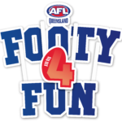

**WHAT’S AFTER AUSKICK?**

**FOR ALL KIDS BORN 1.7.14 – 30.6.16**

**AFLQ.COM.AU/SUPERSTARS**

**MINIMUM AGE IS 7 BY JUNE 30**

**https://www.aflq.com.au/information-about-aflqj**

**WHAT’S COMING UP? (Editable)**

**CENTRE COORDINATOR UPDATE**

**CENTRE COORDINATOR UPDATE**

**DON’T FORGET!**

**CENTRE COORDINATOR UPDATE**

**CENTRE COORDINATOR UPDATE**